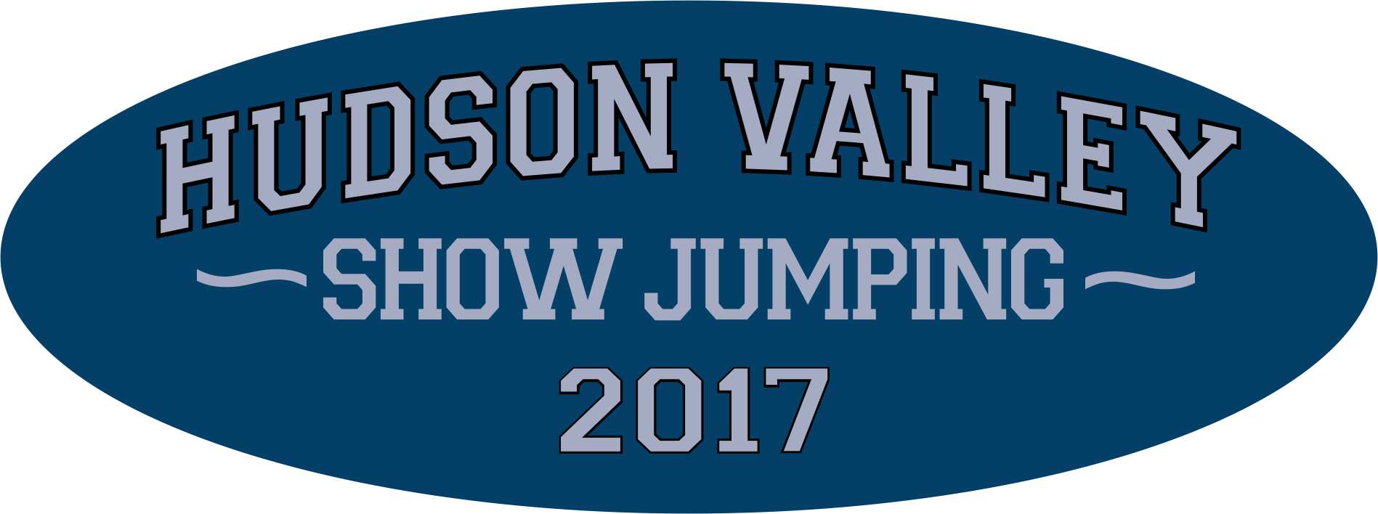

Calling 2017 Hudson Valley Show Jumping Sponsors!

We are excited to be in our 8th year and going strong. With the support of generous sponsors and loyal competitors, we’ve established a tradition of top quality horse shows with charitable giving that just keeps getting better!

2016 marked some exciting milestones for HVSJ, our Sponsors and the charities we serve, including more than $25,000 donated to deserving charities, and growing number of trainers, competitors and spectators.

To keep the momentum going in 2017, we’ve enriched our sponsorship offerings and optimized impact and appeal across five seasonal events, providing:

- Continuous branding and exposure at HVSJ competitions throughout the year
- Visible recognition across the horse show program, promotional posters and the HVSJ website -- all distributed or available throughout the region
- Awareness and affinity generated with a substantial, engaged and loyal audience of equestrians, their families, spectators and entrepreneurs from the Hudson Valley and beyond

What does this mean for deserving charities? Enthusiastic community support, meaningful acknowledgement and financial donations that have totaled over $93,000 to date.

With your help, we can make 2017 Hudson Valley Show Jumping’s most successful year yet. I hope we can count on you!

Sincerely,

Joann Knapp

P.S. Learn more about Hudson Valley Show Jumping events and sponsorships at: www.hudsonvalleyshowjumping.com.

